Architectural Overview – Pilot Phase (Phase 1)

Phase 1 Goal
Validate the end-to-end value of structured prompt capture and agent-based retrieval with human-in-the-loop controls.
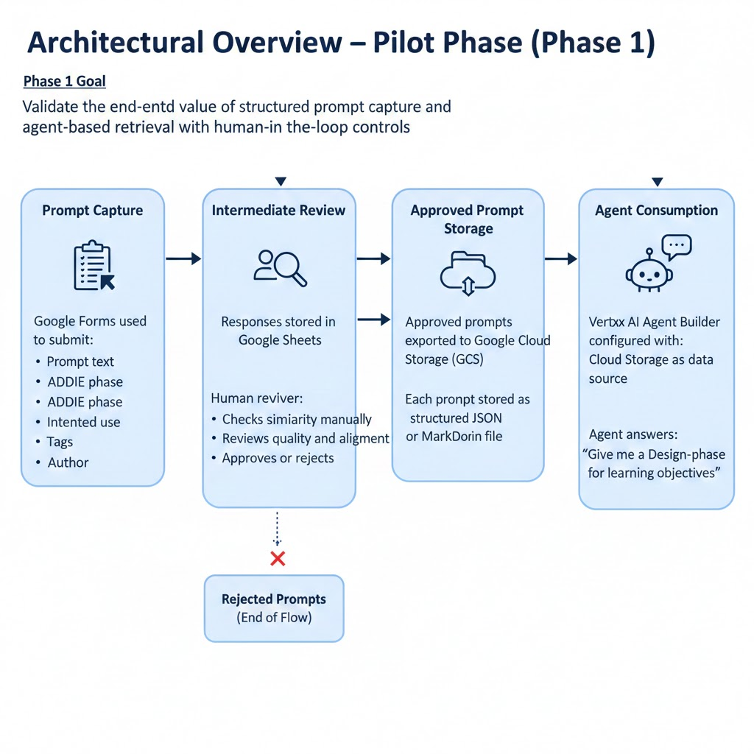

Phase 1 Architecture (Conceptual)
Prompt Capture
- Google Forms used to submit:
  - Prompt text
  - ADDIE phase
  - Intended use
  - Tags
  - Author
Intermediate Review
- Responses stored in Google Sheets
- Human reviewer:
  - Checks similarity manually
  - Reviews quality and alignment
  - Approves or rejects
Approved Prompt Storage
- Approved prompts exported to Google Cloud Storage (GCS)
- Each prompt stored as a structured JSON or Markdown file
Agent Consumption
- Vertex AI Agent Builder configured with:
  - Cloud Storage as a data source
- Agent answers:
“Give me a Design-phase prompt for learning objectives”

Key Characteristics
- Manual similarity detection
- Manual approval
- Simple governance
- Fast to deploy and iterate

Complete Data Flows:
3 End-to-End Flows Documented:
- Adding new prompts (CSV → Function → BigQuery → Vertex AI)
- Searching for prompts (User → Gemini → Search → Results)
- Executing prompts (User → Gemini → Extension → Gemini API → User)

